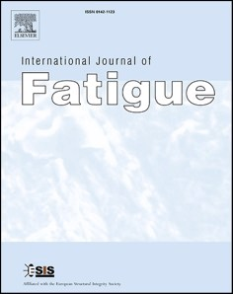[International Journal of Fatigue 158 (2022) 106733](https://doi.org/10.1016/j.ijfatigue.2022.106733)

Contents lists available at [ScienceDirect](http://www.sciencedirect.com/science/journal/01421123)

International Journal of Fatigue

journal homepage: [www.elsevier.com/locate/ijfatigue](https://www.elsevier.com/locate/ijfatigue)

Microstructures and fatigue behaviors of 25CrNi2MoV steel under  electropulsing-assisted ultrasonic surface rolling

Chenfeng Duan a, b, Shengguan Qu a, b,*, Xiongfeng Hu a, b, Siyu Jia b, Xiaoqiang Li b

a *Guangdong Key Laboratory for Advanced Metallic Materials Processing, South China University of Technology, Guangzhou 510640, China*

b *School of Mechanical and Automotive Engineering, South China University of Technology, Guangzhou 510640, China*

A R T I C L E I N F O

*Keywords:* Electropulsing Ultrasound Nanocrystalline Fatigue crack growth Twins

A B S T R A C T

In this paper, the surface modification of 25CrNi2MoV steel was carried out by using electropulsing-assisted ultrasonic surface rolling (EUSR) process. Nano-gradient structures were prepared on the surface and subsur- face of the material. The surface roughness was remarkably reduced. The surface hardness, the surface residual compressive stress and the fatigue resistance of the shaft steel are improved by EUSR treatment. The effect of EUSR treatment on the surface properties and fatigue properties of 25CrNi2MoV steel was systematically studied. The fatigue crack growth mechanism of the specimens after EUSR treatment was mainly discussed. It was concluded that the depth of the hardened and residual stress layers was significantly increased by the EUSR treatment. The fatigue life of the specimens was obviously increased by EUSR treatment. The misorientation of adjacent grains is an important indicator that affects fatigue crack growth.

# Introduction

25CrNi2MoV steel is a new type of shaft material for high-speed and heavy-duty vehicles. Shaft parts are usually in service under compli- cated working conditions such as high temperature, heavy load and corrosive medium [1,2]. Among them, rotating bending fatigue is one of the most important failure modes of shaft parts [3]. The nucleation and propagation of fatigue microcracks on the surface of materials are the main factors affecting the fatigue life of materials. How to suppress the initiation and propagation of cracks is one of the most discussed issues. Therefore, it is an urgent need to improve the fatigue resistance of materials and extend the service life through surface modification technology [4,5,6,7].

Recently, advanced surface modification technologies include laser peening (LSP), ultrasonic surface rolling (USR), chemical vapor depo- sition (CVD) and physical vapor deposition (PVD) [8,9]. Among them, the simplest and most effective method for preparing the surface modification layer is the physical method. In the past studies, it has been proved that the preparation of nanostructures on the surface of materials through plastic deformation can increase the surface hardness of the materials, introduce residual stresses, and increase the fatigue life

[5,7,8,9,10]. USR is to apply constant pressure while introducing ul- trasonic vibration to the tip of the machining tool, and use the rolling tip to carry out surface modification treatment on the material. USR is excellent in reducing surface roughness [11,12]. Zhang et al [13] treated 17-4PH stainless steel with USR technology, he pointed out that ultra- sonic vibration energy provides energy for dislocation distribution at lattice defects and formation of new dislocations. Pandey et al. [14] pointed out in the study that 7075 aluminum alloy exhibited random crystallographic orientations after USR treatment, there is a large den- sity of dislocation network, dislocation tangle and elastic distortion in

the grains, and the low cycle fatigue strength is obvious improve. Dekhtyar [15] studied the influence of USR on the fatigue life of α-Ti

materials, and the results showed that the high-cycle fatigue perfor- mance of the material was slightly improved, mainly due to the reduc- tion of surface roughness. Although USR has excellent performance in reducing surface roughness. However, the ability of USR to improve the grain structure of the subsurface layer of the material is insufficient. This is because the energy provided is very limited.

Electropulsing-assisted manufacturing technology has developed rapidly in recent years. The electropulsing-assisted process is to apply a high-density current to the material, and pass high-intensity energy

* Corresponding author at: Guangdong Key Laboratory for Advanced Metallic Materials Processing, South China University of Technology, Guangzhou 510640, China.

*E-mail addresses:* [18636593866@163.com](mailto:18636593866@163.com) (C. Duan), [qusg@scut.edu.cn](mailto:qusg@scut.edu.cn) (S. Qu), [mehuxiongfeng1992@mail.scut.edu.cn](mailto:mehuxiongfeng1992@mail.scut.edu.cn) (X. Hu), [J15635223374@163.com](mailto:J15635223374@163.com) (S. Jia), [Lixq@scut.edu.cn](mailto:Lixq@scut.edu.cn) (X. Li).

<https://doi.org/10.1016/j.ijfatigue.2022.106733>

Received 29 September 2021; Received in revised form 29 November 2021; Accepted 8 January 2022

Available online 13 January 2022

0142-1123/© 2022 Elsevier Ltd. All rights reserved.

inside the material for a short time. The “thermal effect” will be caused by Joule heating when the instantaneous high-density current passes through the material [16,17,18]. In addition, the pulse current will

accelerate the movement of the dislocation, reduce the resistance of the dislocation to pass through the defect, and improve the plasticity of the

material. This effect is called “electroplasticity” [19,20,21,22,23,24,25].

Okazaki et al. [25] reported that under the action of pulsed current, the dislocation movement speed in Ti was significantly accelerated even at room temperature. Zhu et al. [26] studied the electrical-assisted stretching behavior of ZA22 alloy and found that the elongation of the material after the electropulsing treatment was increased by 437% compared with the original material treatment. This is mainly due to the acceleration of the movement of dislocations and the increase in the density of movable dislocations. The research shows that electropulsing can reduce the deformation resistance of materials and improve the thickness and mechanical properties of nano-layers[27]. Zhang et al.

[28] studied the effect of electropulsing-assisted laser shock peening on Ti64 alloy and found that compared with continuous current, pulse current reduces the flow stress of Ti64 alloy more effectively and a deeper grain refinement layer was obtained. Many current researches only involve the effect of electropulsing-assisted ultrasonic surface rolling (EUSR) treatment on the internal structure of materials, and there is still a lack of in-depth research on the effect of electropulsing on the fatigue behavior of materials.

In this study, 25CrNi2MoV steel was surface modified by EUSR process. The purpose of this study was to investigate the effect of grain refinement layer on fatigue properties after EUSR treatment. The in- fluence of electropulsing on material hardness, surface roughness and residual stress was discussed in detail. The mechanism of fatigue crack propagation in the plastic deformation layer of the specimen after EUSR treatment was clarified. It provides useful information for the strength enhancement of 25CrNi2MoV steel in engineering practice.

# Materials and methods

* 1. *Materials*

25CrNi2MoV steel is a new type of steel material for transmission shaft of high-speed and heavy-duty vehicle gearbox. Chemical compo-

sition of 25CrNi2MoV steel is shown in Table 1. To obtain the untreated specimen (UT), the receiving material was austenitized at 850 ◦C for 0.5

h, then oil quenched, and tempered at 200 ◦C for 2 h. The tensile strength of the UT specimen is 1583 MPa, and the yield strength is 1308 MPa. For surface treatment, the specimen was machined into a round bar specimen with a diameter of 9 mm and a length of 200 mm.

* 1. *EUSR experiment*

The EUSR process is shown in Fig. 1. Electric pulses were applied to the specimen by using a pulse power supply (WSM-400 T). Ultrasonic vibration was provided by an ultrasonic generator (HK30G). In the experiment, the experiment parameters were controlled by the com- puter. The rolling line speed V1 7 m/min and the feed rate V2 1.2 mm/min. The ultrasonic vibration frequency was 27 kHz, the USR static pressure was 1,000 N, and the specimen surface was machined 7 times. Due to the need for insulation between the ultrasonic equipment and the specimen, the rolling tip used in this experiment was a silicon nitride ball with a diameter of 9 mm and a hardness of 78 HRC. The test pa- rameters are shown in Table 2. Mobil 600XP150 lubricating oil was used in rolling to achieve lubrication.

= =

**Table1**

Chemical composition of 25CrNi2MoV steel (wt.%).

* 1. *Fatigue test*

The cantilever beam type rotating bending fatigue test machine (QBWP-10000X) was used for normal temperature fatigue research, and the rotating bending fatigue test was carried out in accordance with the

GB/T 4337–2015 standard. The specimen size is shown in Fig. 2. The

fatigue specimen was machined first and then processed by EUSR. The stress ratio of the fatigue test R -1, and the frequency was 100 Hz. In this study, the step method was used to obtain the fatigue limit of the

=

specimen. The test was terminated when the specimen fails or the number of cycles reaches 107 cycles. The maximum stress value when the specimen reaches 107 stress cycles without failure is called the fa-

tigue limit. Each group of specimens was subjected to 9 fatigue tests.

* 1. *Measurement method*

The metallographic specimens were polished with 600, 800, 1200, and 2000 grit silicon carbide sandpaper before mechanical polishing. A scanning electron microscope (SEM, NOVA NANOSEM 430) was used to observe the microstructure of the cross-section of the metallographic specimen. Moreover, a microhardness tester (SCTMC HV-50) was used to measure the cross-sectional hardness gradient of the specimen. Measured from the surface of the specimen, the depth gradient was 20

μm, the maximum load was 200 N, and the holding time was 15 s.

Moreover, SEM was used to observe the morphology of the fatigue fracture. The surface profile of the specimen was characterized by a three-dimensional white light interference surface profilometer (RTEC UP Dual Model). The measurement area was 0.6 mm 0.8 mm. In addition, the surface roughness was calculated by using Gwyddion software.

×

X-ray diffractometer (XRD, Smartlab-Rigaku) was used to charac- terize the phase structure and grain size of the specimen. The diffraction angle was 20◦-90◦, and the interval step was 0.02◦/s. The X-ray stress

tester (XSTRESS3000-G2) and the classic sin2ψ method were used to measure the residual stress on the surface of the specimen and along the

depth of the layer [29], the residual stress in the axial direction was measured in this study. The tube voltage and tube current were 30 kV and 8 mA, respectively. The residual stress distribution along the depth of the layer was measured by the chemical peeling method, and the

peeling rate was about 1 μm/min. The grain distribution and crystallo-

graphic orientation of the specimen were measured by electron back-

scatter diffraction (EBSD, Thermo Apreo 2) at a voltage of 20 kV. The step size of EBSD orientation mapping was 0.005 μm. The characteristics of the gradient structure in the cross-section of the surface layer of the

specimens were observed by transmission electron microscopy (TEM, JEM 2100F-JEOL) at 200 kV. The TEM specimens were prepared using the focused ion beam technique (FIB, Helios Nanolab 600i).

# Results

* 1. *Microhardness*

Fig. 3 shows the microhardness of various specimens. The surface hardness of the UT specimen was 448.3 HV0.2. The surface hardness of the USR specimen reached 499.7 HV0.2. As shown in Fig. 3(a), the sur- face hardness of the EUSR specimen was significantly greater than that of the USR specimen, and the surface hardness of EUSR-2 reached the maximum value of 624.5 HV0.2. As the pulse current density increases, the surface hardness and the depth of the hardened layer of the specimen increased significantly, as shown in Fig. 3(b). Compared with the USR

|  |  |  |  |  |  |  |  |  |  |  |  |  |
| --- | --- | --- | --- | --- | --- | --- | --- | --- | --- | --- | --- | --- |
| Element | C | Ni | Cr | Mn | Si | Al | Mo | V | Cu | P | S | Fe |
| Content | 0.260 | 2.100 | 1.550 | 0.660 | 0.260 | 0.097 | 0.011 | 0.105 | 0.030 | 0.016 | 0.007 | Bal. |

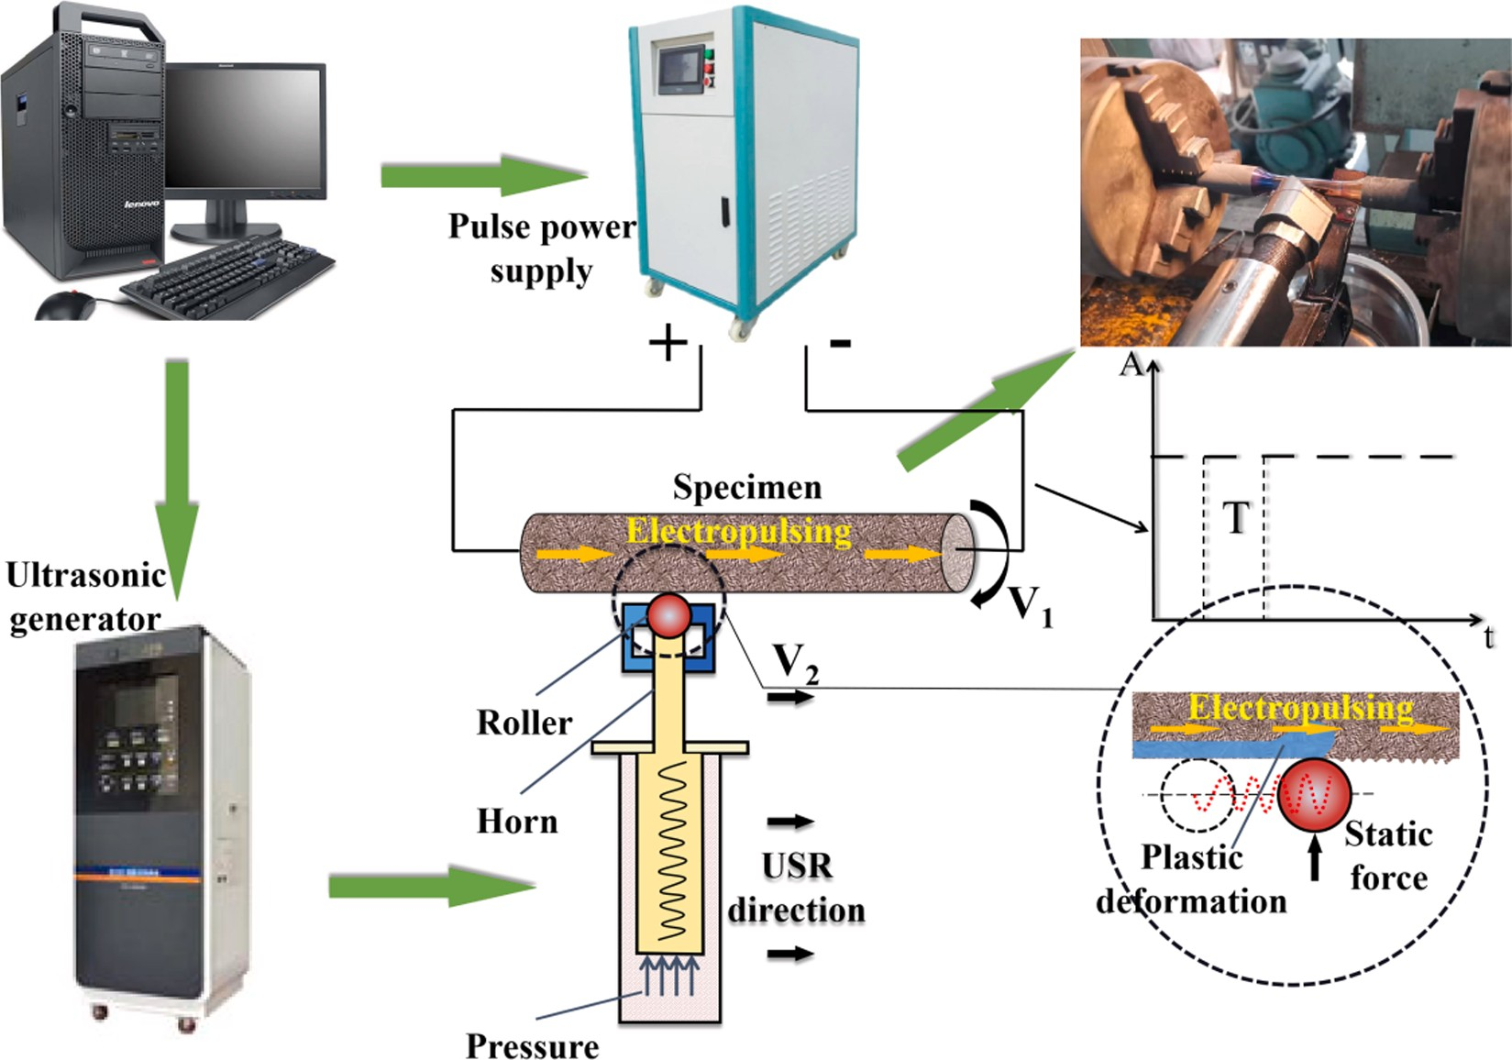

**Table 2**

**Fig. 1.** Schematic diagram of EUSR processing.

* 1. *Surface roughness*

EUSR test parameters.

The fitted surface profile and surface roughness of the different

specimens Frequency

(Hz)

Root- mean- square current

density (A/mm2)

Peak current density (A/mm2)

Duration (μs)

Surface equilibrium temperature (◦C)

processed specimens in the axial direction, as shown in Fig. 4. A clear

turning profile was observed on the surface of the UT specimen, and the surface roughness of the UT specimen was the largest, Ra 0.8169 μm. After the USR treatment, the turning profile of the specimen surface was

=

corrected, but the deeper grooves were not effectively eliminated. It can

UT – – – – 29

USR – – – – 29

EUSR-1 700 0.261 1.072 90 120.3

EUSR-2 700 0.504 1.583 90 181.6

EUSR-3 700 0.755 2.264 90 207.3

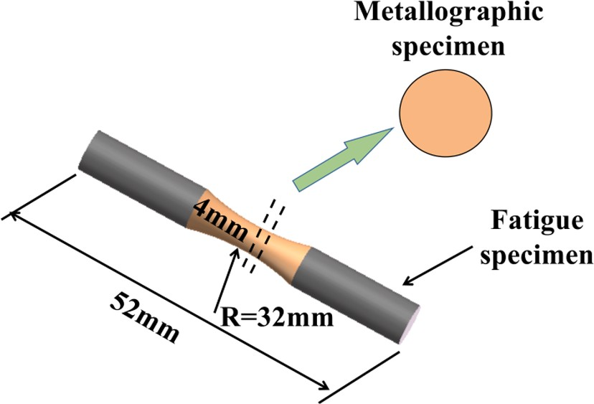

**Fig. 2.** Fatigue specimen.

specimen, the surface hardness of the EUSR-2 specimen increased by 24.9%. Moreover, the depth of the hardened layer was increased by 100

μm, which reveals that EUSR can significantly increase the depth of the

surface hardened layer of 25CrNi2MoV steel.

be seen in Fig. 4 that the undulating valleys introduced by turning were completely eliminated after EUSR treatment. An extremely smooth

surface profile was obtained. The surface roughness of EUSR-2 specimen was the lowest, Ra 0.1173 μm. It is noteworthy that the surface profile of EUSR-3 was slightly higher than that of EUSR-2. The possible reason is

=

that as the plasticity increases, the USR tool caused scratches on the surface of EUSR-3 specimen.

* 1. *XRD analysis*

The XRD method was used to analyze the crystal structure, grain size, peak and other important characteristics of the surface of the specimens before and after the surface treatment. Fig. 5 shows the XRD patterns of various specimens. In Fig. 5(a), it can be seen that the diffraction peak (110) has the highest intensity. It showed that the matrix was composed of martensite. Fig. 5(b) shows an enlarged view of the (110) peak. It can be observed from the figure that the diffraction peaks of the USR and EUSR specimens were significantly shifted compared with the UT specimen. Further, the Bragg diffraction peaks of the main peak (110) were obviously broadened. This is attribute to lattice distortion caused by strong plastic deformation. According to the Scherrer-Wilson method [30], the average grain size was calculated from the full width at half maximum (FWHM) of Bragg diffraction peak of (110). It should be noted that the grain size of the UT specimen cannot be calculated by this method because the grain size is greater than 100 nm. The surface grain sizes of USR, EUSR-1, EUSR-2, EUSR-3 were 81.3 nm, 21.6 nm, 6.3 nm and 5.9 nm, respectively. The results indicated that ultra-fine nano- crystalline layer was prepared on the surface of 25CrNi2MoV steel by

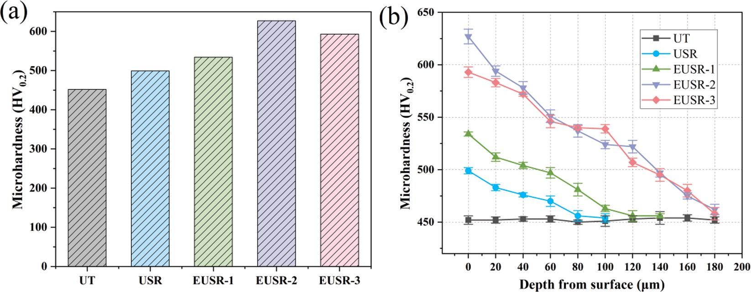

**Fig. 3.** The microhardness of various specimens: (a) surface hardness, and (b) hardness gradient.

depth of the plastic deformation layer of EUSR-1, EUSR-2 and EUSR-3 specimens was much greater than that of USR specimen, reaching 80

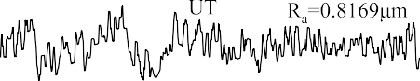

μm, 150 μm and 160 μm, respectively. Furthermore, plastic deformation

was accompanied by severe refinement of surface grains. The results showed that the depth of the plastic deformation layer on the surface of the specimen increases with the increase of the current density of EUSR treatment.

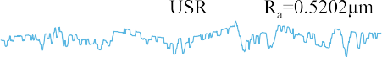

Fig. 7 shows the gradient microstructure of the specimens before and

after the surface treatment. As shown in Fig. 7 (1-a), the martensite width and carbide width of the UT specimen was about 1 μm. In Fig. 7(2- a), it can be observed that the surface layer of the USR specimen was

lamellar martensite. The plastic deformation of martensite at a depth of 10 μm was limited, and only the upper half of the martensite showed slight deformation. At the depth of 30 μm, the USR specimen showed the

original grain. Fig. 7 (3-a) shows the surface microstructure of EUSR-2 specimen. It was found from the figure that an amorphous layer appeared on the surface of the specimen, and the grains of the surface layer were severely refined. Moreover, the carbide size was significantly



reduced to 0.2 μm. The pinning effect of ultra-fine carbides on disloca-

tions increase the hardness and helps to enhance the strength of dispersion strengthening [31]. Insoluble ultra-fine carbides are benefi- cial to improve the wear resistance and fatigue properties of 25CrNi2- MoV steel. Broken martensite and carbide can be observed in Fig. 7 (3-b, c). This may be because the randomly distributed dislocations rearrange and move along the slip line under the action of pulse current and stress. As the deformation continues and the crystallographic orientation in- creases, the dislocation tangles with high density leads to the fracture of lath martensite and carbides, forming ultra-fine grains and carbides



**Fig. 4.** Surface roughness of specimens before and after surface treatment.

EUSR treatment. It is noted that the diffraction peak of Fe3O4 was observed in the XRD pattern of the EUSR-3 specimen, because the

temperature of the EUSR-3 specimen reached 200 ℃ during the EUSR

treatment. The surface of the specimen undergoes oxidation reaction at high temperature and generates a small amount of Fe3O4, which is the reason why the hardness of EUSR-3 specimen is slightly lower than that of EUSR-2 specimen.

* 1. *Plastic deformation*

Fig. 6 shows the morphology of the surface microstructures of various specimens. In Fig. 6(a), it can be observed that the UT specimen was composed of lath martensite, and a small amount of granular car- bide was contained in the lath martensite collective. Fig. 6(b) shows the microstructure of the USR specimen. The plastic deformation layer of

the USR specimen was only 10 μm, which was caused by the high plastic

deformation resistance of 25CrNi2MoV steel. As depicted in Fig. 6, the

[32]. Fig. 7 (3-d) shows the microstructure at 50 μm below the surface of

the EUSR-2 specimen. Lath martensite presented a fibrous structure, and the metal flow direction was consistent with the processing direction. The plastic deformation layer and hardened layer of EUSR specimens consist of this gradient structure.

* 1. *Residual stress*

As we all know, residual stress is an important indicator for fatigue performance. Fig. 8 shows the residual stresses of specimens after various surface treatments. All kinds of specimens showed residual compressive stress. The residual stress of the UT specimen was intro- duced by mechanical processing. The surface residual stresses of UT, USR and EUSR specimens were 37.6, 351.4, 416.3, 583.3 and

— — — —

458.6 MPa, respectively. Fig. 8(b) shows that the residual compressive

—

stress of the UT specimen was not related to the depth gradient. The residual stress depth of the USR specimen reached 150 μm and decreased with increasing depth. The maximum residual compressive stress of the specimens after EUSR treatment all appeared at 50 μm below the sur- face. The residual compressive stress of EUSR-2 specimen was the

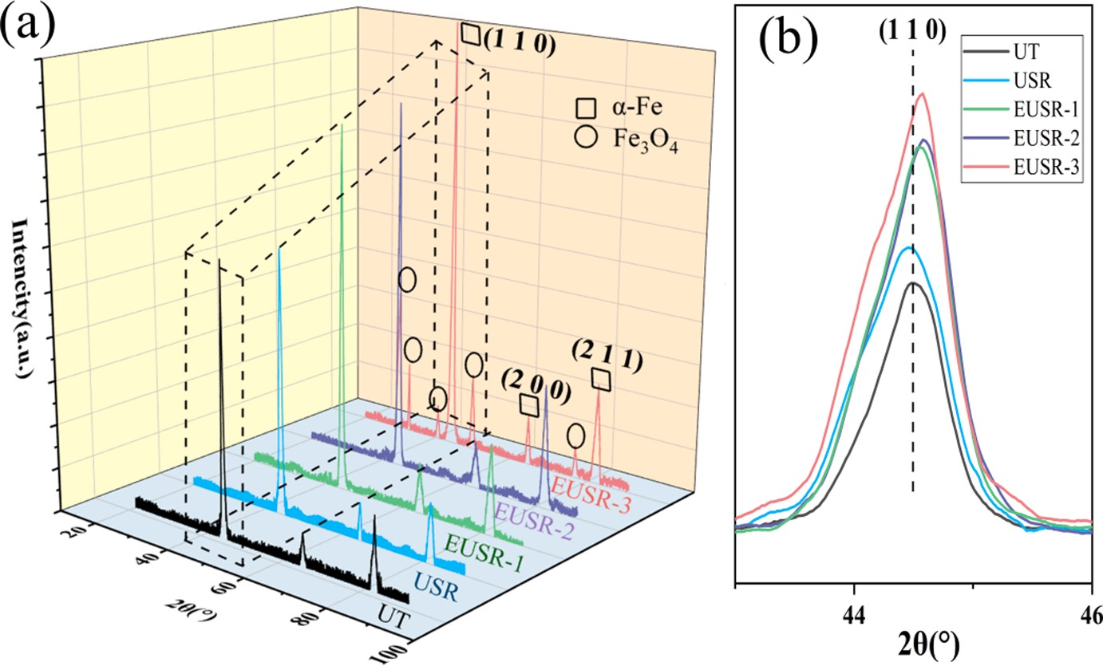

**Fig. 5.** XRD patterns of various specimens.

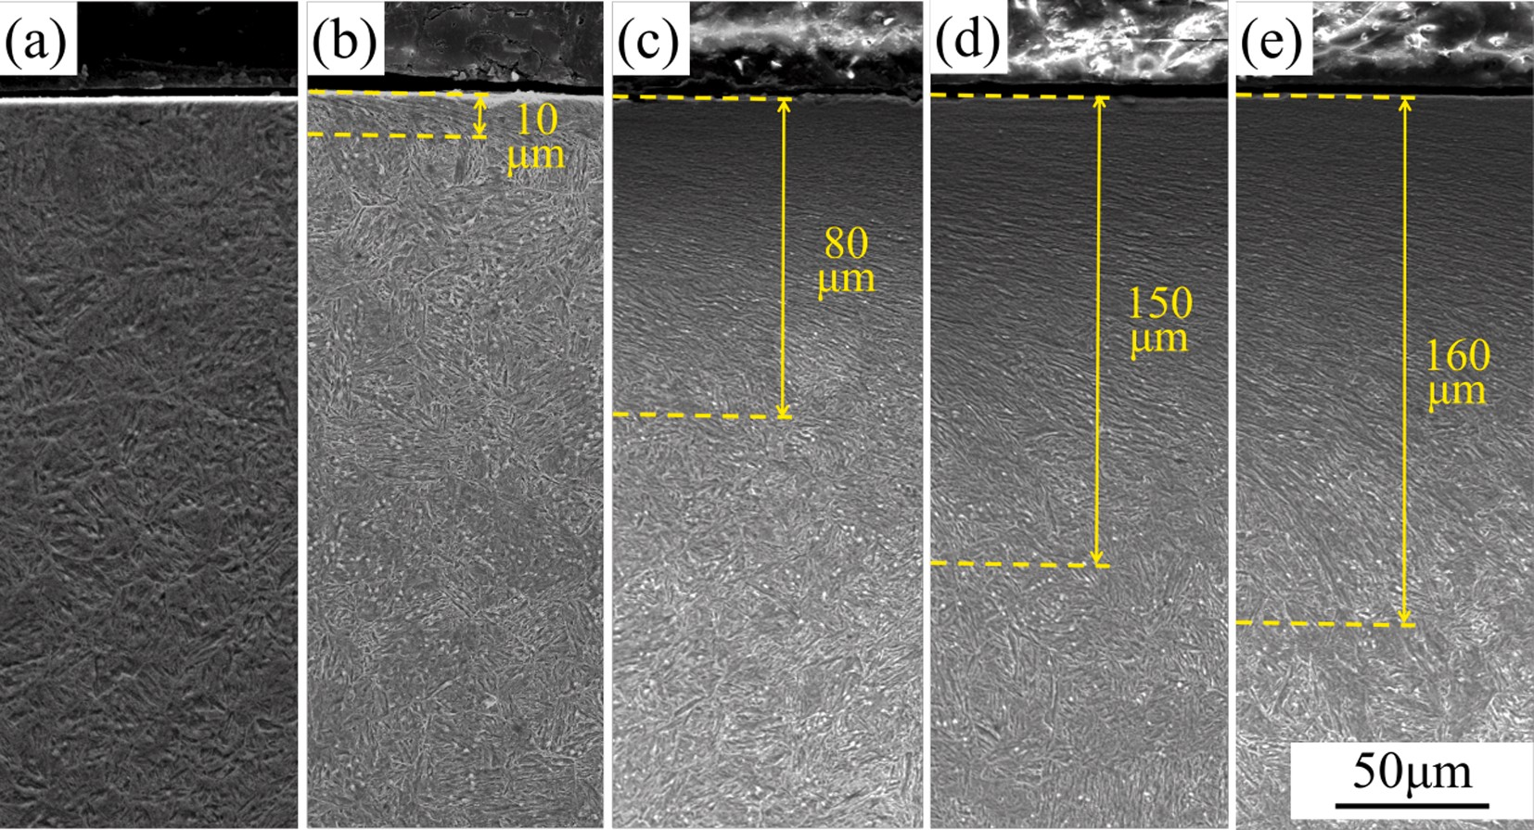

**Fig. 6.** Surface microstructure morphology of various types of specimens: (a) UT, (b) USR, (c) EUSR-1, (d) EUSR-2, and (e) EUSR-3 specimens.

largest, which was 849.5 MPa. The measurement results showed that the introduction of electropulsing was beneficial to increase the residual stress of the specimen after USR treatment. Moreover, the depth of the residual stress layer of the specimens after EUSR treatment increased significantly. The distribution depth of the residual stress layer increases with the increase of current density. It is noteworthy that the residual stress of the EUSR-3 specimen has decreased. The possible reason is that

—

the temperature of EUSR-3 specimen reached 200 ◦C during the pro-

cessing, and part of the residual stress is released at high temperatures. Therefore, the residual compressive stress distribution on the surface of 25CrNi2MoV steel can be improved according to the adjustment of the pulse current parameters, thereby reducing the risk of stress concen- tration failure.

* 1. *EBSD and TEM analysis*

Fig. 9 shows the EBSD of the gradient plastic deformation layer of EUSR-2 specimen and UT specimen. The different grain orientations in the figure were marked with different colors. In Fig. 9 (a, b), it was

observed that the grains of the plastic deformation layer of EUSR-2 specimen were severely refined compared with the UT specimen. Fig. 9 (c, d) shows the corresponding grain size distribution map. The

grain diameter of the UT specimen was 12.7 μm, while the average

diameter of the surface refined grains of the EUSR-2 specimen reached

15.3 nm. After EUSR treatment, the specimens recrystallized due to severe plastic deformation. Compared with the UT specimen, the grain distribution in the gradient plastic deformation layer was randomly oriented. Kernel average misorientation (KAM) is an important index to evaluate the degree of plastic deformation and grain orientation of materials. The misorientation increases with the increase of KAM value.

From Fig. (e, f), it can be observed that the average value of KAM in the plastic deformation layer of EUSR-2 specimen (KAM 1.755◦) was

=

larger than that of UT specimen (KAM 0.875◦). After EUSR treatment, the grains in the gradient plastic deformation layer were severely refined. Besides that, the misorientation of adjacent grains has increased. Relevant studies have shown that the propagation mechanism of cracks in lath martensite is seriously affected by the orientation of adjacent grains and their interfaces [33]. It was found that the

=

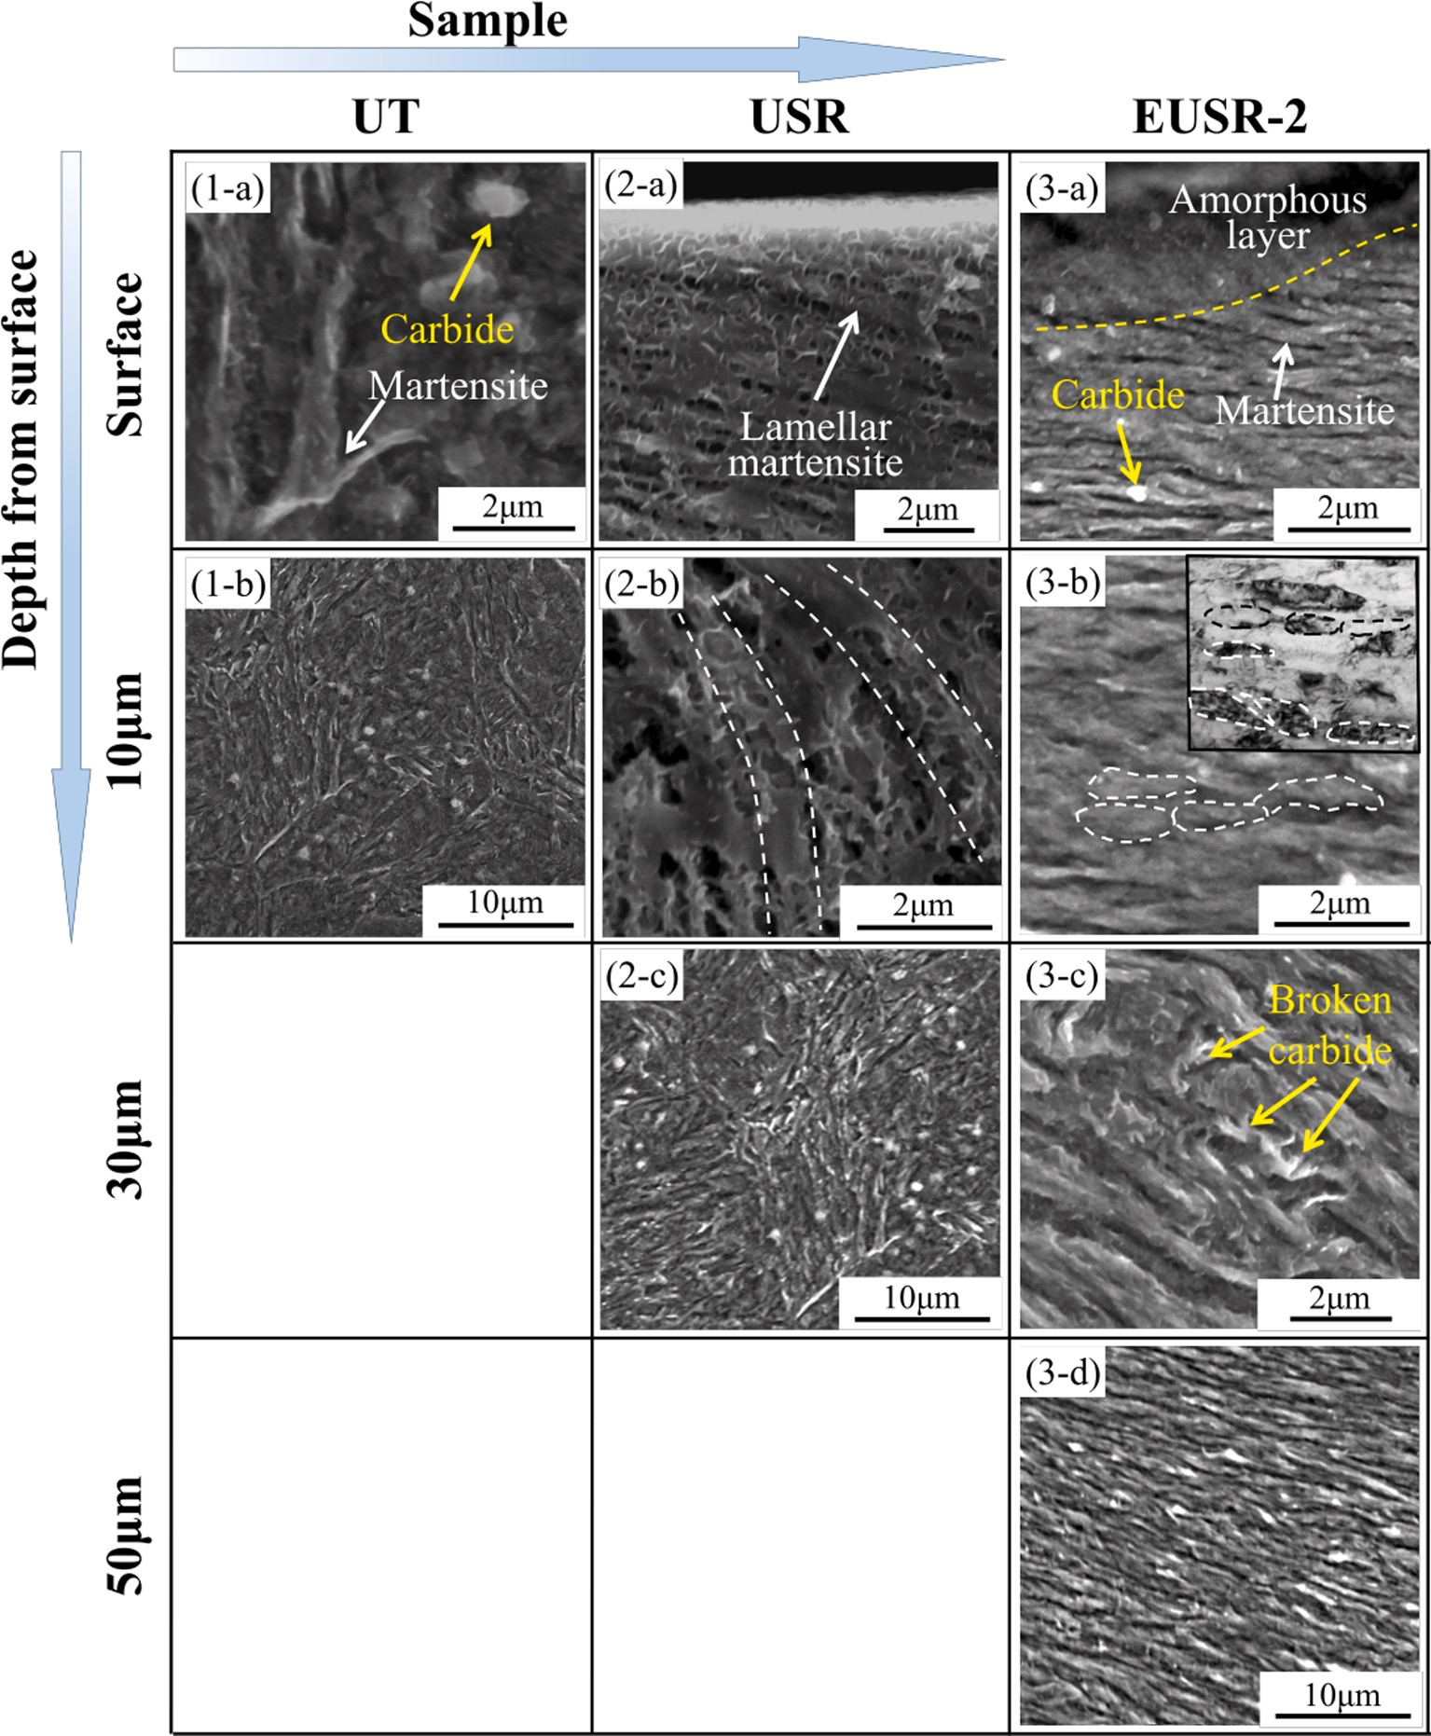

**Fig. 7.** Plastic deformation layer of various specimens.

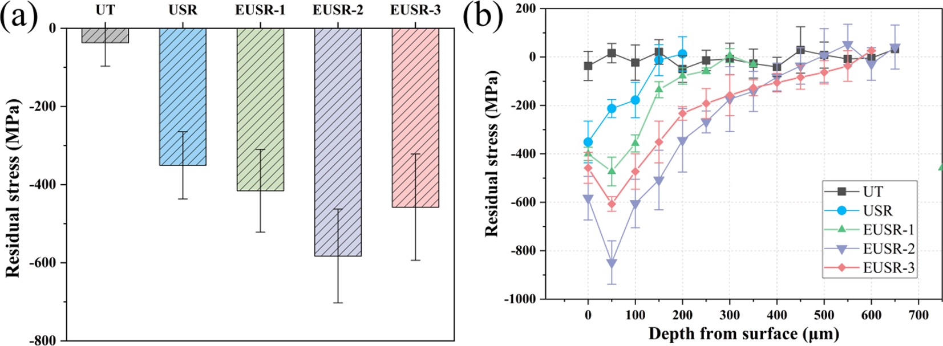

**Fig. 8.** Residual stress of various specimens: (a) surface residual stress, and (b) change of residual stress with depth gradient.

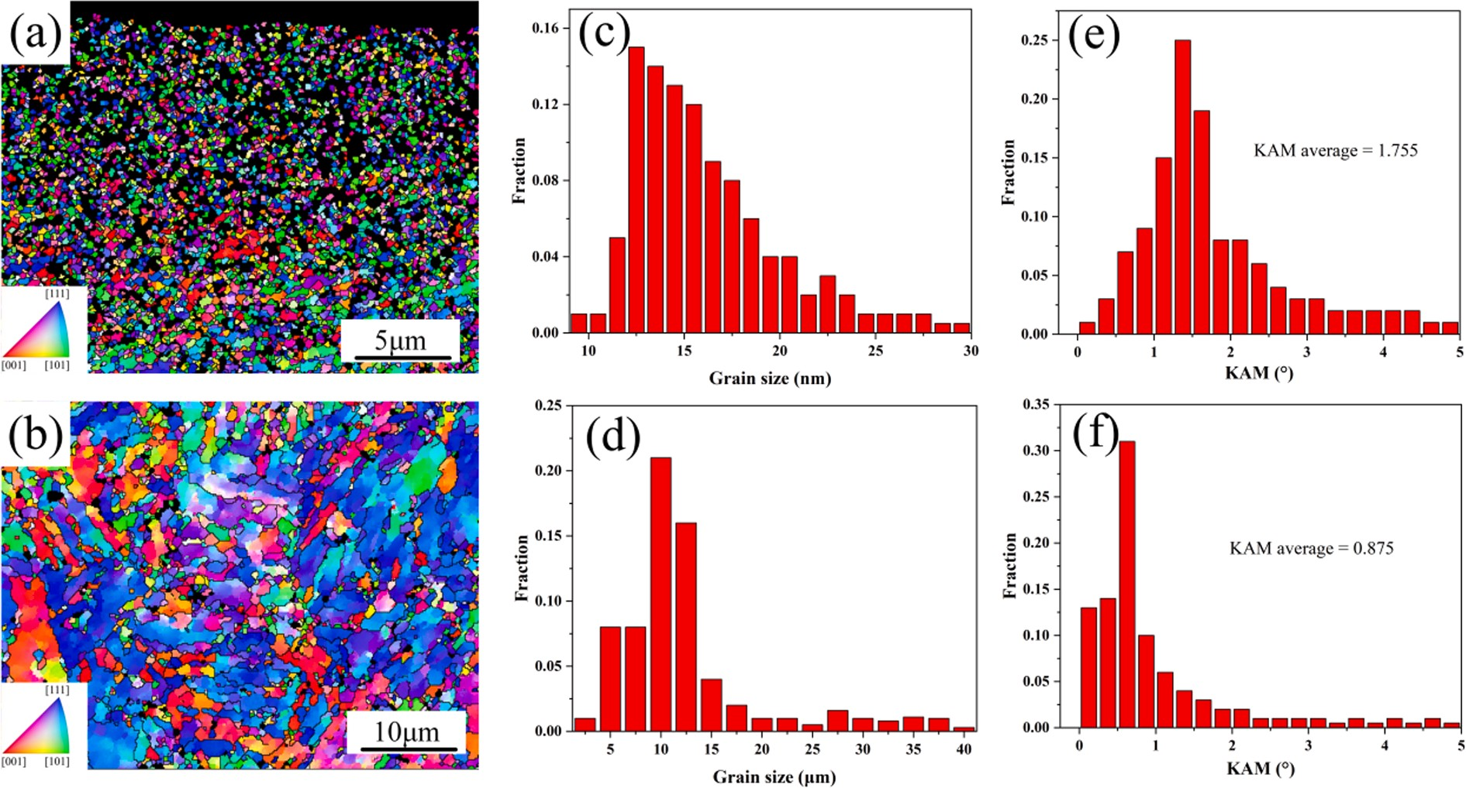

**Fig. 9.** The EBSD of the cross-section of the gradient plastic deformation layer of the specimen: (a) the inverse pole figure (IPF) of the EUSR-2 specimen, (b) the IPF of the UT specimen, (c,d)) are the grain size histograms corresponding to (a, b), and (e, f) are the KAM histograms corresponding to (a, b), respectively.

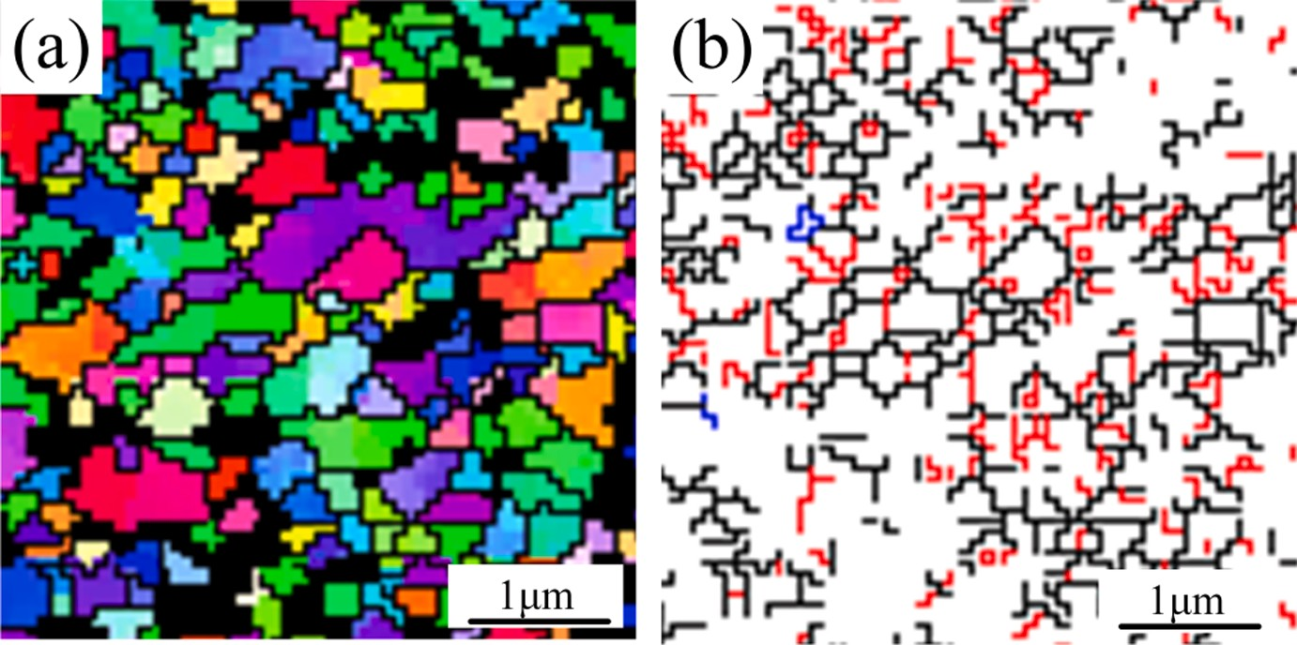

**Fig. 10.** EBSD at a depth of 10 μm below the surface of EUSR-2 specimen: (a) IPF and (b) distribution of sub-grain boundaries and twin boundaries (black lines indicate large-angle grain boundaries, with grain misorientation greater than 10◦; red lines indicate small-angle grain boundaries, and the misorientation of grains is greater than 2◦ and less than 10◦). (For interpretation of the references to colour in this figure legend, the reader is referred to the web version of this article.)

orientation-dependent phenomenon is responsible for the expansion of cracks in nano-scale grains [34].

Fig. 10 shows the distribution of IPF and subgrain boundaries or twins at a depth of 10 μm below the surface of the EUSR-2 specimen. It can be seen that there were a large number of sub-grain boundaries or

twin grain boundaries in the grains of the gradient plastic deformation layer after the grain refinement occurs. This due to the increase in dislocation mobility caused by high-density electropulsing [35]. Qin

[36] et al. pointed out that the instantaneous energy generated can reduce the resistance of dislocations through internal defects of the crystal when an electropulsing was applied to the material. 25CrNi2- MoV steel has a body-centered cubic structure, and dislocations tend to move along the [110] slip surface [37]. A large number of dislocations cross and move inside the crystal grains. Due to the continuous anni- hilation and arrangement of the dislocations, dense dislocation tangles and dislocation cells are formed inside the crystal grains. At the same time, the plastic deformation of the material was accompanied by the

formation of twins. Combining the results of dislocation tangles and deformation twins, a large number of sub-grain boundaries and twin boundaries were generated inside the refined grains, as shown in Fig. 10 (b). Numerous studies have reported that sub-grain boundaries and twin boundaries can effectively hindered the movement of dislocations and improve the resistance to crack propagation [38,39,40].

TEM observation of the cross-section of the topmost layer of the EUSR-2 specimen was performed, as shown in Fig. 11. Obviously, nano- sized equiaxed grains were distributed throughout the gradient plastic

deformation layer, and the grain size was mainly in the range of 20–30

nm. Fig. 11(b) shows the corresponding selected area electron diffrac- tion (SAED) pattern, where the SAED pattern of the topmost grain exhibited a continuous diffraction ring, which confirmed that the topmost grain had a random crystallographic orientation. In Fig. 11(c), a large number of fine twins were found in the matrix. It can be observed by high-resolution transmission electron microscopy that the surface of the specimen was composed of dislocations in disordered states, as

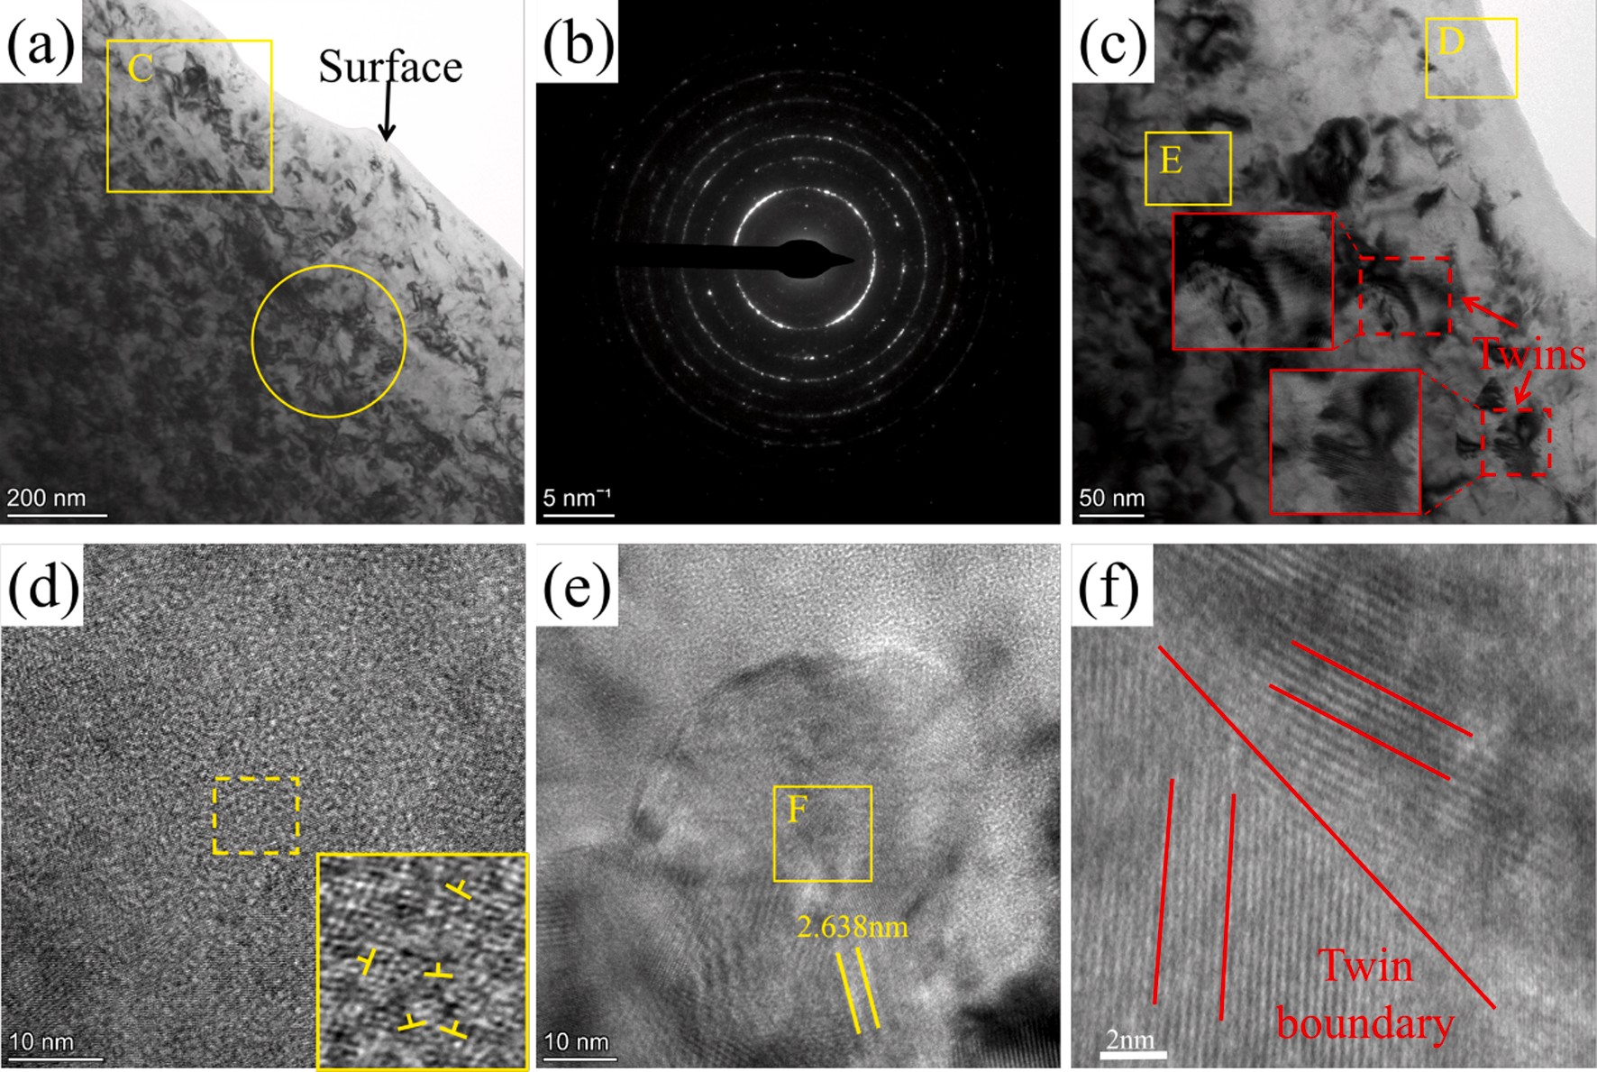

**Fig. 11.** (a) TEM of the cross section of the topmost layer of EUSR-2 specimen, (b) the corresponding SAED, (c) the designated area in figure (a), (d) a large number of dislocation tangles on the surface, (e) a crystal grain surrounded by dislocation clusters, and (f) twin boundary.

shown in Fig. 11(d), where a large number of dislocations were cross- piled, and the lattice ordering was disrupted. Fig. 11(e) shows a crys- tal grain surrounded by dislocation clusters. The grain boundary hinders the movement of the dislocation and causes dislocation tangle at the grain boundary. A large number of nano-pitch stacking faults and twins were displayed in the crystal grains, and the twins may be caused by stacking faults. Fig. 11(f) shows the twin boundarie inside the grain, confirming the results of the EBSD analysis.

* 1. *Fatigue performance*
     1. *S-N curve*

Fig. 12 shows the fatigue S-N curves of various specimens. The test results were marked with various symbols, and the regression line was

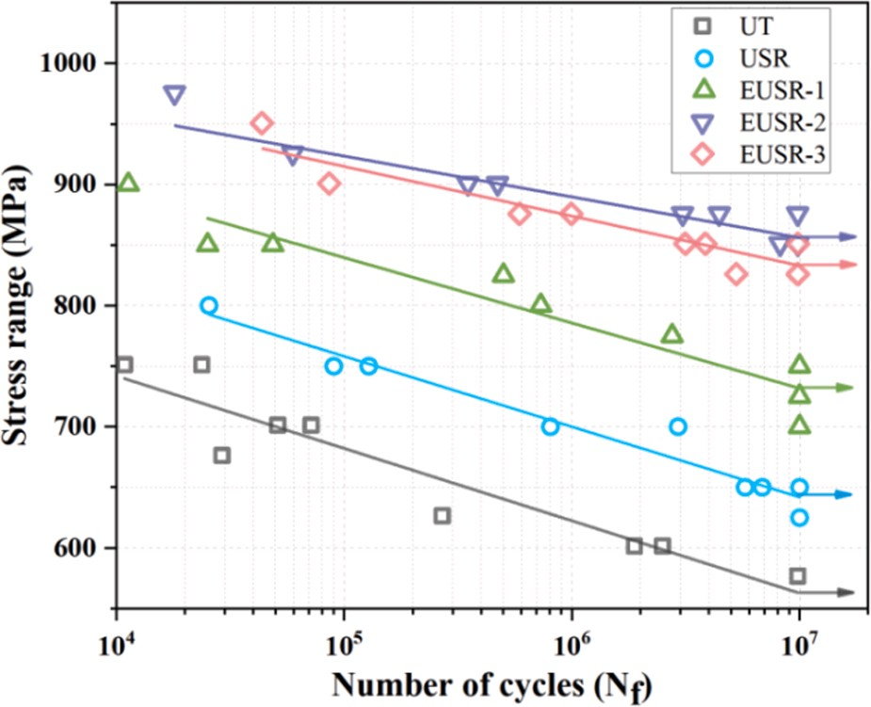

**Fig. 12.** S-N curve.

the result obtained by linear fitting based on the fatigue test data of various specimens. The arrow marked the specimen whose fatigue life (Nf) reaches 107 cycles without failure (i.e. fatigue limit). It can be found

from the figure that the S-N curve of the UT specimen was located at the

bottom of the figure, indicated that the fatigue limit of the UT specimen was the lowest, which was 565 MPa. Stress amplitude (σa) is one of the important factors affecting fatigue life. It can be observed in Fig. 12 that

the increase in stress amplitude was accompanied by a decrease in fa- tigue life. The strain and strain accumulation rate of the material in- crease with the stress amplitude, which leads to the accelerated destruction of the material [41]. The EUSR-2 specimen has the highest fatigue limit, which was about 300 MPa higher than that of the UT specimen. Further, the slope of the regression line of the EUSR-2 spec- imen was the lowest, indicates that the EUSR-2 specimen has the highest fatigue stability. This is mainly due to the introduction of residual stress on the surface of the specimen by EUSR treatment. The stress amplitude affects the stress relaxation process. As the stress amplitude increases, the relaxation life of the residual compressive stress was significantly reduced [42]. The EUSR-2 specimen has the highest residual stress, and the fatigue limit of the specimen was improved by extending the relaxation life of the residual compressive stress.

* + 1. *Fatigue failure analysis*

Fig. 13 shows the SEM of the fatigue fracture of the UT, USR and EUSR-2 specimens. The morphology in Fig. 13(a) shows that the UT specimen was a typical fatigue fracture. The region I (fatigue source) indicated that the fatigue cracks of the UT specimen have grown on the surface. As shown in Fig. 13(b), a large number of tearing edges formed by crack propagation were observed near the crack source. The region III (final fracture region) of the fatigue fracture of the UT specimen was a typical orthogonal dimple, indicates that the UT specimen has good toughness. Fig. 13(d-f) shows the fatigue fracture of a USR specimen. It

can be observed from Fig. 13(e) that the fatigue crack originated 15 μm

below the surface, just below the gradient plastic deformation layer. The

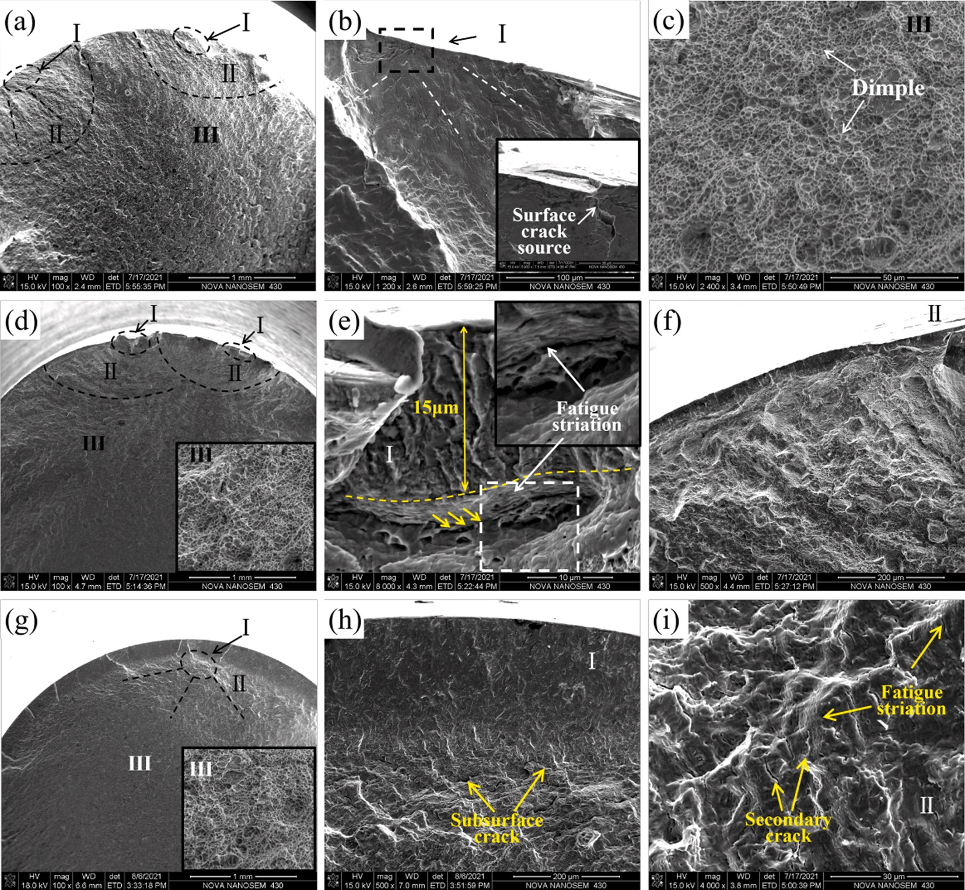

**Fig. 13.** Fatigue fracture morphology of various specimens: (a, b, c) UT, σa = 600 MPa, Nf = 1,912,977 cycles, (d, e, f) USR, σa = 650 MPa, Nf = 6,855,717 cycles and (g, h, i) EUSR-2, σa = 875 MPa, Nf = 4,518,370 cycles.

fatigue striation can be clearly observed below the gradient plastic deformation layer, and the fatigue crack propagated along the interface between the gradient plastic deformation layer and the substrate (as shown by the yellow arrow in the figure). Fig. 13(f) shows a few cleavage steps. At the same time, there were a large number of dimples in the final fracture region, which indicates that the USR specimen exhibited a ductile fracture with low plasticity.

Fig. 13 (g-i) shows the fatigue fracture of the EUSR-2 specimen. In the figure, the gradient plastic deformation layer can be directly observed, and the fatigue cracks were initiated under the gradient plastic deformation layer. In Fig. 13(h), a large number of secondary cracks were also found under the gradient plastic deformation layer. Compared with the number of cracks in the original material, the gradient plastic deformation layer appeared as a smoother plane, and the number of cracks in the plastic deformation layer was significantly smaller. The results indicated that the gradient plastic deformation layer, hardened layer and residual stress layer introduced by EUSR treatment can significantly inhibit the propagation of cracks. Fig. 13(i) shows the crack propagation region of EUSR-2 specimen. In the figure, a large number of fatigue striations were clearly observed to expanded in different planes, but a large number of cleavage planes and secondary

cracks were also found. The results showed that EUSR-2 specimen exhibited ductile–brittle mixed fracture.

Fig. 14 shows the locations of fatigue crack initiation of various specimens. It can be observed from the figure that the UT specimen cracked from the surface during the fatigue crack, which was caused by the intrusion and extrusion of the material surface during the test. The

graded plastic deformation layer can be clearly observed in the fatigue fracture of the USR and EUSR specimens, and fatigue cracks originate at the interface between the plastic deformation layer and the original material. The depth of the plastic deformation layer of the USR specimen

was 15 μm. The EUSR-2 and EUSR-3 specimens have the deepest plastic deformation layer with a depth of 200 μm. In particular, the residual stress of the EUSR-2 specimen at a depth of 200 μm below the surface was greater than 400 MPa. It is inferred that EUSR treatment can

—

improve the fatigue life by increasing the surface plastic deformation layer and residual stress layer depth of 25CrNi2MoV steel.

In order to clarify the mechanism of increasing fatigue life of 25CrNi2MoV steel by gradient plastic deformation layer. Fig. 15 shows the SEM of the gradient plastic deformation layer of the EUSR-2 spec- imen and the interface between the deformation layer and the original material. Fig. 15(b,c) shows enlarged views of designated areas in Fig. (a), respectively. In Fig. 15(b), a large number of fatigue striations and a small number of microcracks were observed in the gradient plastic deformation layer. An enlarged view of the interface, in which a large number of fatigue cracks and fatigue striations were found, as shown in Fig. 15(c). The propagation direction of the crack was perpendicular to the fatigue striations. The growth rate of cracks increase with the continuous increase of the width of fatigue striations. The existence of a large number of secondary cracks at the interface indicated that the fatigue resistance of the original material was lower than that of the gradient plastic deformation layer. Uniform fatigue striations and a small number of micro-cracks in the deformed layer were excellent performance in fatigue resistance. The gradient plastic deformation

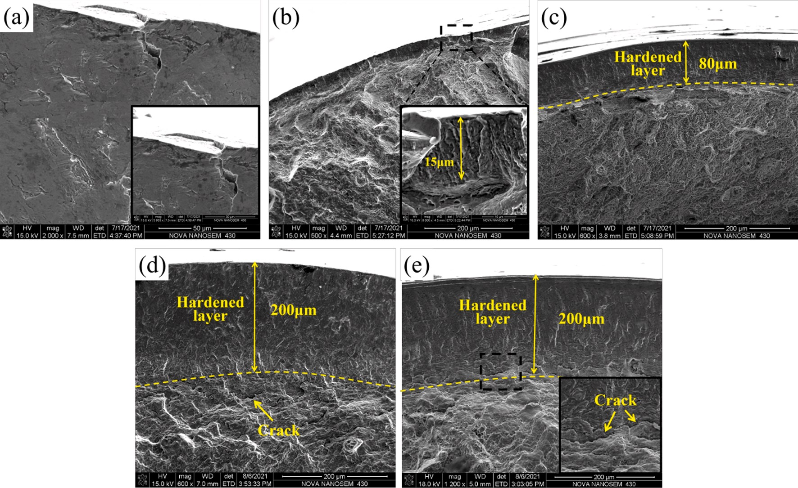

**Fig. 14.** Fatigue crack source of various specimens: (a) UT, σa = 625 MPa, Nf = 273,251 cycles, (b) USR, σa = 650 MPa, Nf = 6,855,717 cycles, (c) EUSR-1, σa = 775 MPa, Nf = 2,758,743 cycles, (d) EUSR-2, σa = 875 MPa, Nf = 4,518,370 cycles and (e) EUSR-3, σa = 850 MPa, Nf = 3,918,682 cycles.

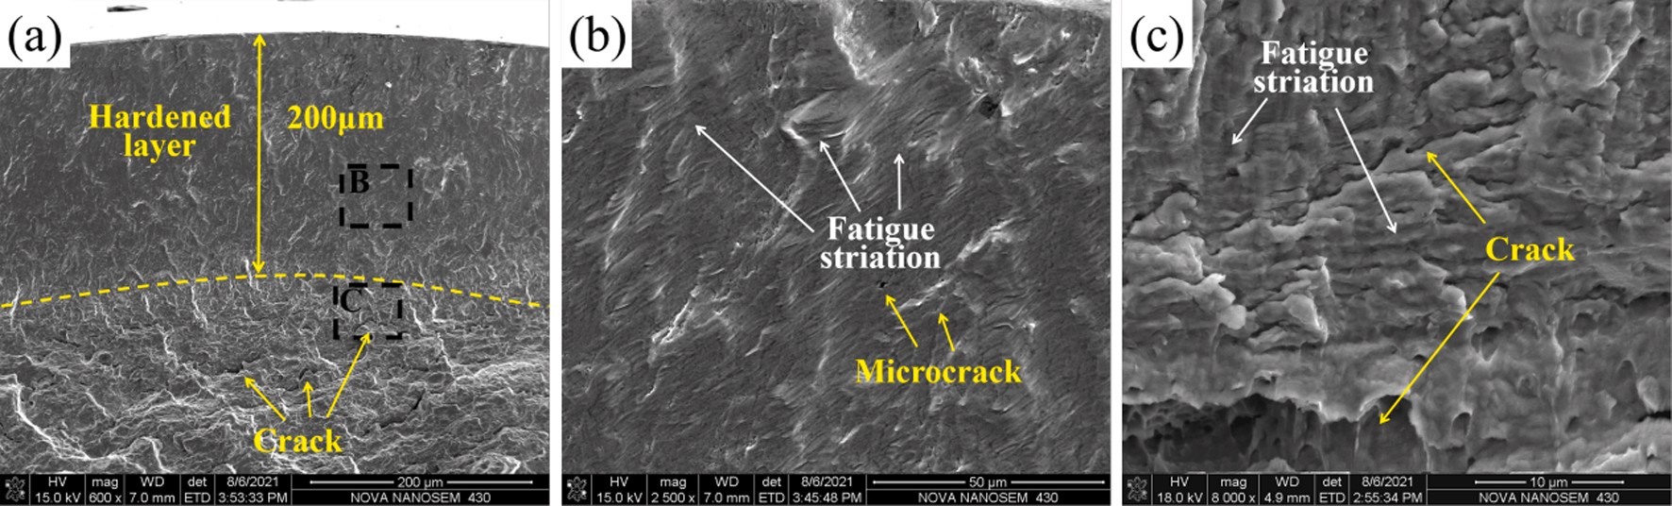

**Fig. 15.** SEM of the interface between the gradient plastic deformation layer and the deformed layer and the original material (EUSR-2, σa = 875 MPa, Nf =

4,518,370 cycles): (b,c) are enlarged views of the designated area in Fig. (a).

layer can effectively inhibit the propagation of cracks and increase the fatigue life of 25CrNi2MoV steel.

# Discussion

Fig. 16 shows a schematic diagram of fatigue crack growth of different structures of EUSR specimen. After EUSR treatment, a gradient plastic deformation layer (i.e., grain refinement layer) was formed on the surface of the specimen, and the misorientation of grains in the grain refinement layer was larger than that of the original grains. Fatigue crack growth was carried out by the movement of dislocations. As shown in Fig. 16(b), the dislocations move within the grain along the Out-of- habit-plane slip system. Due to the different orientations of the grains on both sides of the grain boundary, the slip plane and the slip direction are not consistent. Therefore, it is difficult for dislocations to pass through grain boundaries. Dislocations are blocked near the grain boundaries, and a large number of dislocation pile-up and dislocation tangles are generated near the grain boundaries. Furthermore, the re- sidual stress introduced by EUSR treatment can inhibit the propagation of cracks. The misorientation and residual stress work together to inhibit

the initiation and propagation of fatigue cracks. In the end, only microcracks will be generated in the grain refinement layer, as shown in Fig. 12(b). Due to the large grain size and small misorientation of the original grains, the dislocations are easy to move to adjacent grains and cause rapid crack propagation, as shown in Fig. 16(c).

The sub-grain boundaries inside the grains of the refined layer are also important structures that hinder the movement of dislocations. Related studies have shown that the nucleation of fatigue cracks at the phase interface can be significantly suppressed, thereby enhanced the resistance to high-cycle fatigue failure [43]. In addition to suppressed crack initiation, sub-grain also enhanced the resistance to fatigue crack growth by changed the stress/strain distribution around the crack tip [44].

# Conclusions

1. EUSR treatment significantly improved the surface hardness of 25CrNi2MoV steel and introduces high residual compressive

stress. The surface hardness has increased by 24.9%. The surface roughness was reduced to 0.1173 μm.

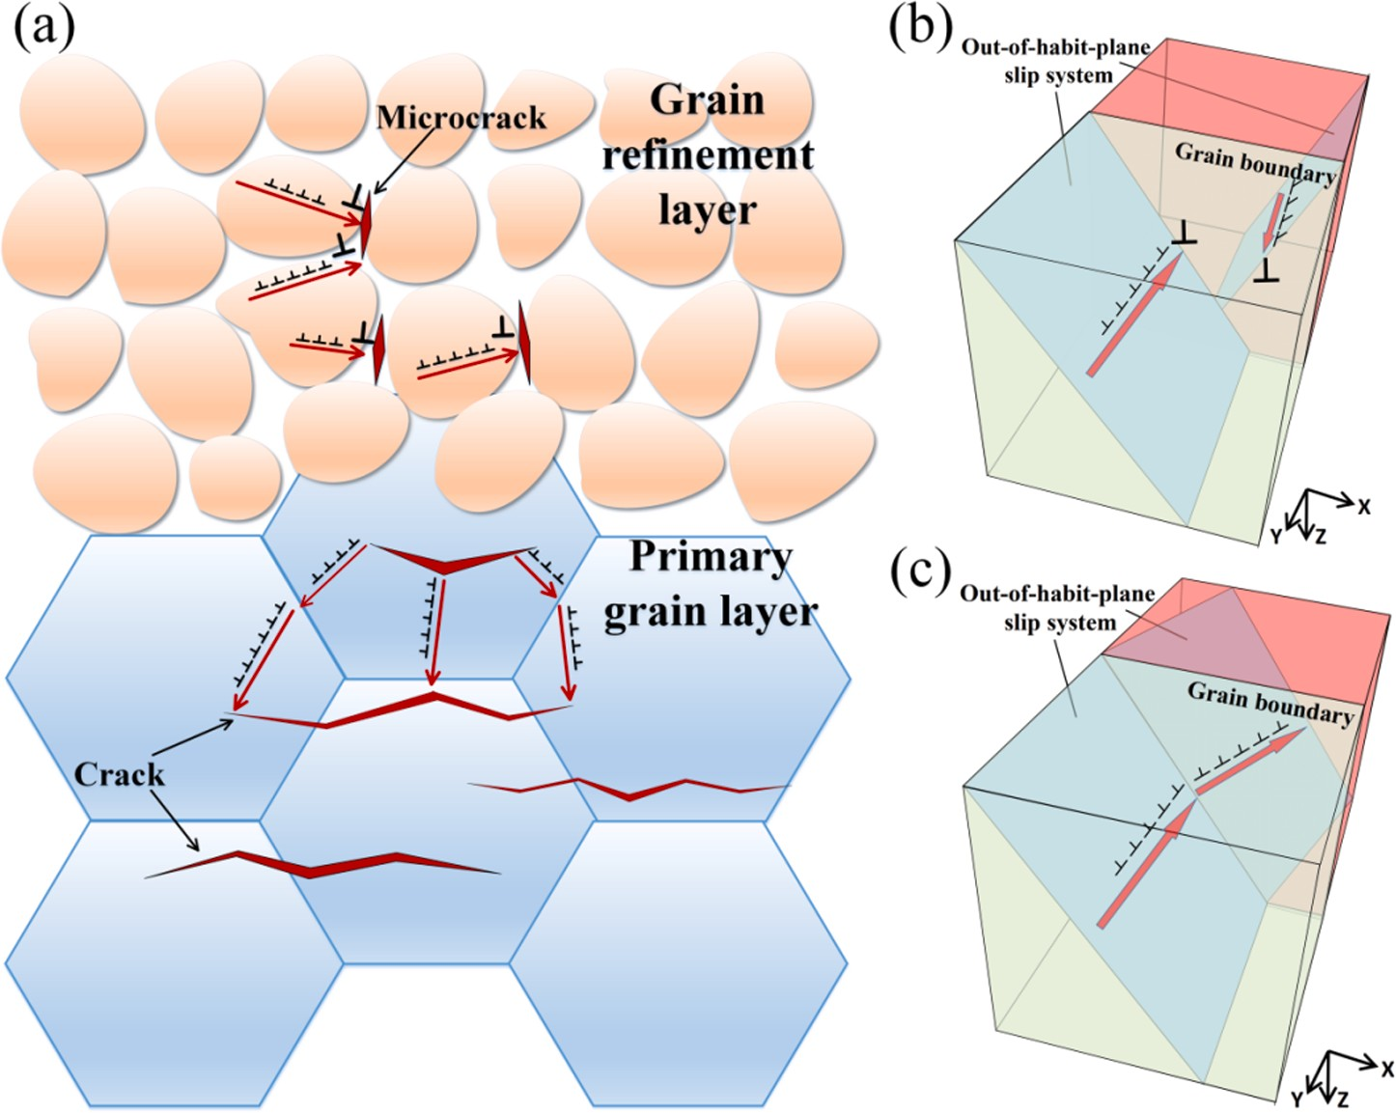

**Fig. 16.** Schematic diagram of fatigue crack growth of different structures of EUSR specimen.

1. EUSR treatment has prepared nanocrystals on the surface of

25CrNi2MoV steel, and the maximum depth of the gradient plastic deformation layer was 160 μm. The effective hardened layer thickness was 200 μm.

1. The misalignment of adjacent grains in the gradient plastic deformation layer was larger than that of the original material. EUSR treatment significantly increases the sub-grain boundaries and twin boundaries within the ultra-fine grains.
2. The fatigue limit of the specimen after EUSR treatment was significantly increased under the combined effect of grain refinement, residual compressive stress and hardened layer, which was increased by about 300 MPa.

# Formatting of funding sources

This work was supported by the Guangdong Province Key Area R&D Program, Guangdong Science and Technology Department [grant numbers 2020B090926003], and Basic and Applied Basic Research Foundation of Guangdong Province [grant numbers 2021A1515012394], and Zhuhai Industry Education and Research Cooperation Project [grant numbers ZH22017001200011PWC].

# Declaration of Competing Interest

The authors declare that they have no known competing financial interests or personal relationships that could have appeared to influence the work reported in this paper.

# Acknowledgments

The authors would like to thank the National Engineering Research Center of Near-Net-Shape Forming for Metallic Materials.

# References

1. Bhadeshia HKDH. Steels for bearings. Prog. Mater Sci. 2012;57(2):268–435. <https://doi.org/10.1016/j.pmatsci.2011.06.002>.
2. Buling A, S¨andker H, Stollenwerk J, Krupp U, Steinmeier AH. Laser surface

pretreatment of 100Cr6 bearing steel-hardening effects and white etching zones. Appl. Surf. Sci. 2016;378:564–71. <https://doi.org/10.1016/j.apsusc.2016.03.088>.

1. Hella M, Wagenerb R, Kaufmannb H, Melza T. Fatigue life design of components

under variable amplitude loading with respect to cyclic material behaviour. Proceed. Eng. 2015;101:194–202. <https://doi.org/10.1016/j.proeng.2015.02.025>.

1. Martini C, Palombarini G, Poli G, Prandstraller D. Sliding and abrasive wear

behaviour of boride coatings. Wear 2004;256(6):608–13. [https://doi.org/](https://doi.org/10.1016/j.wear.2003.10.003) [10.1016/j.wear.2003.10.003](https://doi.org/10.1016/j.wear.2003.10.003).

1. Majumdar JD, Chandra BR, Nath AK, Manna I. In situ dispersion of titanium boride on aluminium by laser composite surfacing for improved wear resistance. Surf. Coat. Technol. 2006;201(3-4):1236–42. [https://doi.org/10.1016/j.](https://doi.org/10.1016/j.surfcoat.2006.01.048)

[surfcoat.2006.01.048](https://doi.org/10.1016/j.surfcoat.2006.01.048).

1. Straede CA, Mikkelsen NJ. Implementation of ion implantation in European industry. Surf. Coat. Technol. 1996;84(1-3):567–73. [https://doi.org/10.1016/ S0257-8972(95)02821-8](https://doi.org/10.1016/S0257-8972(95)02821-8).
2. Zhang J, Peng P, She J, Jiang B, Tang A, Pan F, et al. A study of the corrosion behavior of AZ31 Mg alloy in depth direction after surface nanocrystallization. Surf. Coat. Technol. 2020;396:125968. [https://doi.org/10.1016/j.](https://doi.org/10.1016/j.surfcoat.2020.125968) [surfcoat.2020.125968](https://doi.org/10.1016/j.surfcoat.2020.125968).
3. Graetzel M, Janssen RAJ, Mitzi DB, Sargent EH. Materials interface engineering for solution-processed photovoltaics. Nature 2012;488(7411):304–12. [https://doi. org/10.1038/nature11476](https://doi.org/10.1038/nature11476).
4. [Bell LE. Cooling, heating, generating power, and recovering waste heat with thermoelectric systems. Science 2008;321(5895):1457–61](http://refhub.elsevier.com/S0142-1123(22)00014-7/h0045).
5. Liu G, Lu J, Lu K. Surface nanocrystallization of 316L stainless steel induced by

ultrasonic shot peening. Mater. Sci. Eng. A 2000;286(1):91–5. [https://doi.org/](https://doi.org/10.1016/S0921-5093(00)00686-9) [10.1016/S0921-5093(00)00686-9](https://doi.org/10.1016/S0921-5093(00)00686-9).

1. Li G, Qu S, Xie MingXin, Li X. Effect of ultrasonic surface rolling at low temperatures on surface layer microstructure and properties of HIP Ti-6Al-4V

alloy. Surf. Coat. Technol. 2017;316:75–84. [https://doi.org/10.1016/j.](https://doi.org/10.1016/j.surfcoat.2017.01.099)

[surfcoat.2017.01.099](https://doi.org/10.1016/j.surfcoat.2017.01.099).

1. Ye Y, Kure-Chu S-Z, Sun Z, Li X, Wang H, Tang G. Nanocrystallization and enhanced surface mechanical properties of commercial pure titanium by

electropulsing-assisted ultrasonic surface rolling. Mater. Des. 2018;149:214–27.

<https://doi.org/10.1016/j.matdes.2018.04.027>.

1. Zhang Q, Hu Z, Su W, Zhou H, Liu C, Yang Y, et al. Microstructure and surface properties of 17–4PH stainless steel by ultrasonic surface rolling technology. Surf. Coat. Tech. 2017;321:64–73. <https://doi.org/10.1016/j.surfcoat.2017.04.052>.
2. Pandey V, Chattopadhyay K, Santhi Srinivas NC, Singh V. Role of ultrasonic shot peening on low cycle fatigue behavior of 7075 aluminium alloy. Int. J. Fatig. 2017; 103:426–35. <https://doi.org/10.1016/j.ijfatigue.2017.06.033>.
3. [Dekhtyar AI, Mordyuk BN, Savvakin DG, Bondarchuk VI, Moiseeva IV, Khripta NI. Enhanced fatigue behavior of powder metallurgy Ti–6Al–4V alloy by applying](http://refhub.elsevier.com/S0142-1123(22)00014-7/h0075) [ultrasonic impact treatment. Mater Sci Eng, A 2015;641:348–59](http://refhub.elsevier.com/S0142-1123(22)00014-7/h0075).
4. Ross CD, Kronenberger TJ, Roth JT. Effect of dc on the formability of Ti-6Al-4V. J. Eng. Mater. Technol. 2009;131:031004. <https://doi.org/10.1115/1.3078307>.
5. Siopis MS, Kinsey BL. Experimental investigation of grain and specimen size effects during electrical-assisted forming. J. Manuf. Sci. Eng. 2010;132:021004. [https:// doi.org/10.1115/1.4001039](https://doi.org/10.1115/1.4001039).
6. Perkins TA, Kronenberger TJ, Roth JT. Metallic forging using electrical flow as an alternative to warm/hot working. J. Manuf. Sci. Eng. 2007;129:84–94. [https://doi.](https://doi.org/10.1115/1.2386164) [org/10.1115/1.2386164](https://doi.org/10.1115/1.2386164).
7. Zheng K, Wang C, Cheng Y-Q, Yue Y, Han X, Zhang Ze, et al. Electron-beam- assisted superplastic shaping of nanoscale amorphous silica. Nat. Commun. 2010;1 (1). <https://doi.org/10.1038/ncomms1021>.
8. A.J. S´anchez Egea, H.A. Gonz´alez Rojas, D.J. Celentano, J.A. Travieso-Rodríguez,

J. Llum`a, i Fuentes, Electroplasticity-assisted bottom bending process, J. Mater. Process. Technol. 214 (2014) 2261-2267. https://doi.org/doi:10.1016/j. jmatprotec.2014.04.031.

1. Liu X, Lan S, Ni J. Experimental study of electro-plastic effect on advanced high strength steels. Mater. Sci. Eng. A 2013;582:211–8. [https://doi.org/10.1016/j. msea.2013.03.092](https://doi.org/10.1016/j.msea.2013.03.092).
2. [Conrad H. Electroplasticity in metals and ceramics. Mater. Sci. Eng. A 2000;287(2): 276–87](http://refhub.elsevier.com/S0142-1123(22)00014-7/h0110).
3. Mai J, Peng L, Lin Z, Lai X. Experimental study of electrical resistivity and flow stress of stainless steel 316L in electroplastic deformation. Mater. Sci. Eng. A 2011;

528(10-11):3539–44. <https://doi.org/10.1016/j.msea.2011.01.058>.

1. Guillon O, Els¨asser C, Gutfleisch O, Janek J, Korte-Kerzel S, Raabe D, et al.

Manipulation of matter by electric and magnetic fields: Toward novel synthesis and processing routes of inorganic materials. Mater. Today 2018;21(5):527–36. <https://doi.org/10.1016/j.mattod.2018.03.026>.

1. Okazaki K, Kagawa M, Conrad H. A study of the electroplastic effect in metals. Scripta Metall. 1978;12(11):1063–8. [https://doi.org/10.1016/0036-9748(78)](https://doi.org/10.1016/0036-9748(78)90026-1) [90026-1](https://doi.org/10.1016/0036-9748(78)90026-1).
2. Zhu YH, To S, Lee WB, Liu XM, Jiang YB, Tang GY. Effects of dynamic electropulsing on microstructure and elongation of a Zn-Al alloy. Mat. Sci. Eng. A 2009;501(1-2):125–32. <https://doi.org/10.1016/j.msea.2008.09.080>.
3. Wang H, Song G, Tang G. Evolution of surface mechanical properties and

microstructure of Ti-6Al-4V alloy induced by electropulsing-assisted ultrasonic surface rolling process. J. Alloys Compd. 2016;681:146–56. [https://doi.org/](https://doi.org/10.1016/j.jallcom.2016.04.067) [10.1016/j.jallcom.2016.04.067](https://doi.org/10.1016/j.jallcom.2016.04.067).

1. Zhang H, Ren Z, Liu J, Zhao J, Liu Z, Lin D, et al. Microstructure evolution and electroplasticity in Ti64 subjected to electropulsing-assisted laser shock peening. J. Alloys Compd. 2019;802:573–82. [https://doi.org/10.1016/j.](https://doi.org/10.1016/j.jallcom.2019.06.156)

[jallcom.2019.06.156](https://doi.org/10.1016/j.jallcom.2019.06.156).

1. [Prevey PS. X-ray Diffraction Residual Stress Techniques. ASM Handbook Materials Characterization. ASM International; 1986](http://refhub.elsevier.com/S0142-1123(22)00014-7/h0145).
2. Williamson GK, Hall WH. X-ray line broadening from filed aluminium and wolfram. Acta Metall. 1953;1(1):22–31. [https://doi.org/10.1016/0001-6160(53)](https://doi.org/10.1016/0001-6160(53)90006-6) [90006-6](https://doi.org/10.1016/0001-6160(53)90006-6).
3. Dobrica MB, Fillon M. Performance degradation in scratched journal bearings. Tribol. Int. 2012;51:1–10. <https://doi.org/10.1016/j.triboint.2012.02.003>.
4. Mishra A, Kad B, Gregori F, Meyers M. Microstructural evolution in copper

subjected to severe plastic deformation: experiments and analysis. Acta Mater. 2007;55(1):13–28. <https://doi.org/10.1016/j.actamat.2006.07.008>.

1. Mine Y, Hirashita K, Takashima H, Matsuda M, Takashima K. Micro-tension behaviour of lath martensite structures of carbon steel. Mater. Sci. Eng. A 2013;

560:535–44. <https://doi.org/10.1016/j.msea.2012.09.099>.

1. Zhao ZF, Qin ZY, Chu FL. Atomistic scale fracture behavior of the bcc iron with 110 crack under dynamic rectangular loading rate. Comput. Mater. Sci. 2019;158:

178–91. <https://doi.org/10.1016/j.commatsci.2018.11.020>.

1. Conrad H, White J, Cao WD, Lu XP, Sprecher AF. Effect of electric current pulses on

fatigue characteristics of polycrystalline copper. Mater. Sci. Eng. A 1991;145(1): 1–12. <https://doi.org/10.1016/0921-5093(91)90290-4>.

1. Rahnama A, Qin R. Room temperature texturing of austenite/ferrite steel by electropulsing. Sci. Rep. 2017;7:42732. <https://doi.org/10.1038/srep42732>.
2. Prahl J, Machov´a A, Landa M, Hauˇsild P, Karlík M, Spielmannov´a A, et al. Fracture

of Fe–3wt.% Si single crystals. Mater. Sci. Eng. A 462 2007;462(1-2):178–82. <https://doi.org/10.1016/j.msea.2006.02.456>.

1. Arola D, Williams C. Estimating the fatigue stress concentration factor of machined surfaces. Int. J. Fatig. 2002;24(9):923–30. [https://doi.org/10.1016/S0142-1123 (02)00012-9](https://doi.org/10.1016/S0142-1123(02)00012-9).
2. D. Wu, Ch Yao, D. Zhang, Surface characterization and fatigue evaluation in GH4169 superalloy: comparing results after finish turning; shot peening and surface polishing treatments, Int. J. Fatig. 113 (2018) 222-235. https://doi.org/ 10.1016/j.ijfatigue.2018.04.009.
3. Zhang H, Chiang R, Qin H, Ren Z, Hou X, Lin D, et al. The effects of ultrasonic

nanocrystal surface modification on the fatigue performance of 3D-printed Ti64. Int. J. Fatig. 2017;103:136–46. <https://doi.org/10.1016/j.ijfatigue.2017.05.019>.

1. Xiong Y, Jiang YY. Fatigue of ZK60 magnesium alloy under uniaxial loading. Int. J.

Fatig. 2014;64:74–83. <https://doi.org/10.1016/j.ijfatigue.2014.02.019>.

1. Madhavi Y, Krishna LR, Narasaiah N. Influence of micro arc oxidation coating

thickness and prior shot peening on the fatigue behavior of 6061–T6 Al alloy. Int J Fatig. 2019;126:297–305. <https://doi.org/10.1016/j.ijfatigue.2019.05.013>.

1. Lei YB, Wang ZB, Xu JL, Lu K. Simultaneous enhancement of stress- and strain- controlled fatigue properties in 316L stainless steel with gradient nanostructure.

Acta Mater. 2019;168:133–42. [https://doi.org/10.1016/10.1016/j.](https://doi.org/10.1016/10.1016/j.actamat.2019.02.008)

[actamat.2019.02.008](https://doi.org/10.1016/10.1016/j.actamat.2019.02.008).

1. Xu X, Lv Y, Hu M, Xiong Di, Zhang L, Wang L, et al. Influence of second phases on fatigue crack growth behavior of nickel aluminum bronze. Int. J. Fatig. 2016;82: 579–87. <https://doi.org/10.1016/j.ijfatigue.2015.09.014>.